**Project Name**: Cat Marine Advanced Variable DriveTM - Innovative Vessel Design

**Project Location**: Istanbul, Turkey

**Award Category**: Mitigation or Adaptation to Climate Change

**Team Members**: Nathan Kelly, Igor Strashny, Jim Mundth, Ali Gürün, Ozer Ilhan, Tamer Geckin **Date**: 4 May 2018

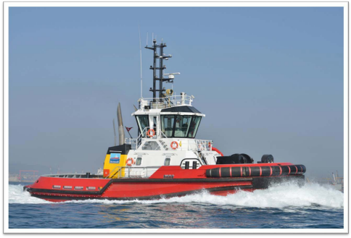

*“The strategic development of this hybrid solution by Sanmar and Caterpillar will provide a highly optimized, lower cost alternative to conventional electric hybrid systems – with similar benefitsregarding improved performance, lower noise, and lower emissions.”* Ali Guran, Director of Projects, Sanmar Shipyards(Photo of RAmparts 2400-SX Harbor Tug courtesy of Sanmar Shipyards)

Caterpillar: Confidential Green

**Summary**

**Project Description**

For more than 100 years, Caterpillar has been changing the way customers do business around the world. Over the past decade, Caterpillar engineers have developed hybrid and advanced drive technologies for the construction and mining industries. Now, the Advanced Variable DriveTM (AVDTM) System by Caterpillar Marine brings this renowned innovation to marine propulsion, resulting in new levels of operating efficiency.

The AVDTM system provides significant improvements in both fuel efficiency and vessel performance through a fully integrated hydro-mechanical propulsion system. Different from a typical Power Take In (PTI) solution, the AVDTM incorporates a planetary gear set allowing seamless clutch engagement of main engines, auxiliary engines, or both to provide a scalable power installation to meet any customer need in terms of maximum vessel speed, power, or bollard pull. This allows propeller speed independent of engine speed so optimal engine efficiency can be achieved, leading to a fuel savings of 15% to 20%. Basically, all the benefits of a variable speed Diesel Electric Propulsion system at a fraction of the cost and size.

The AVDTM system is also flexible and can accommodate multiple configurations. Auxiliary engines can be utilized to accommodate low load or transit operations greatly extending time to overhaul and reducing service costs on main engines. Electric motors can also be used instead of hydraulics if required. AVDTM enables straight forward integration of either diesel, natural gas or gas turbine engines or any combination of these as prime movers, accommodating various levels of engine load acceptance capability and engine speed regimes. As a direct result, main engines can be downsized in most applications, with supplemental power provided by auxiliary engines. The system provides inherently high levels of propulsion redundancy. It is fully scalable to meet requirements of a wide range of vessel types, application, and power levels.

To demonstrate the value of this technology, Caterpillar Marine partnered with Sanmar Shipyards to integrate this innovative hydraulic hybrid propulsion system into a tugboat design. The *Boğaçay XXXVIII* will be the 38th vessel built to the Sanmar exclusive design. However, it will be the first hybrid version. Optimized for harbour tug operations, the compact tug design includes 70 Tonnes of Bollard Pull and Fire Fighting (Fi-Fi) Level 1 capability. Propulsion equipment will feature Caterpillar 3512C main engines, Caterpillar MTA627 azimuthing thrusters, and a C32 auxiliary engine powering both the hybrid hydraulics as well as the Fi-Fi pump.

Compared to traditional tugs the hydraulic hybrid propulsion system on the Boğaçay XXXVIII will dramatically reduce fuel consumption and carbon emissions. Given the propensity for tugboats to work in waters near populated coastlines and in big city ports, the ability of this technology to mitigate climate change in a meaningful and measurable way is both promising and exciting.

2

Caterpillar: Confidential Green

**Goal**

The strategic development goal between Caterpillar and Sanmar was to create a highly optimized, lower cost alternative tugboat design, with similar benefits as conventional electric hybrid systems regarding improved vessel performance, lower noise, and lower emissions.

**Objectives**

The primary objectives for this demonstration project, include the following:

1. Collaborate with other industry leaders to design an innovative hydraulic hybrid solution 2. Deliver 15-20% fuel efficiency improvement over conventional tugboat design 3. Increase operational efficiency with customizable operating modes, improved tugboat responsiveness, maneuverability and positioning

4. Decrease environmental impacts, to include: fossil fuels and lubricants, noise and air pollution

5. Reduce owning and operating costs over conventional tugboats

**Accomplishments**

Industry leading, the *Boğaçay XXXVIII* will be the first hydraulic hybrid vessel of its kind – providing the same benefits of a variable speed Diesel-Electric Propulsion (DEP) system at a fraction of the size and cost. Considering the perceived benefits of DEP systems, this is a tremendous accomplishment in terms of vessel design.

Second, the innovative design of this vessel facilitates the downsizing of the main engines from two Cat 3516s to two Cat 3512Cs and one Cat C32. With the AVDTM,the hydraulic hybrid propulsion system selectively runs the engines (Cat 3512C or Cat C32) at higher load factors, thereby generating significantly higher fuel efficiency over conventional tugboats.

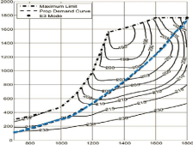Figure 1. Cat 3516 Fuel Contour Map – Conventional Tug

As a baseline, Figure 1 depicts the fuel contour map for a 3516-main engine in a conventional tugboat operation. Historically, main engines operate 3000 hours per year, but at a very low load factor. The blue dotted line depicts the Prop Demand Curve. When operating at this load factor 100% of the time, fuel efficiency is not optimal.

3

Caterpillar: Confidential Green

In contrast, the engines on the *Boğaçay XXXVIII* will 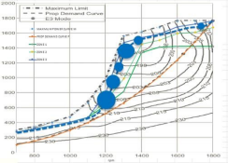

divide the annual work load of 3000 hours per year.

Rather than bearing the load 100% of the time at a

low load factor with two 3516 main engines,

downsized 3512Cs will only run 15% of the time (~450

hours per year) at a much higher load factor. As

depicted on the fuel contour map on the right (Figure

2), this optimizes the fuel efficiency and performance

of this engine.

Figure 2. Cat 3512 Fuel Contour Map

Given the efficiency of the hydraulic hybrid 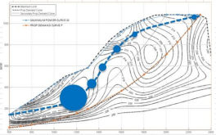

propulsion system, most of the annual

work load will be supported by a Cat C32

Auxiliary Engine. This engine will run 85%

of the time (~2550 hours per year) also at

a higher load factor, which optimizes fuel

efficiency and performance. See Figure 3.

Figure 3. Cat C32 Fuel Contour Map

As illustrated above, this project demonstrates the true value of AVDTM technology and its ability to reduce fuel consumption and therefore, carbon emissions. When fully integrated into vessel design, propeller speed can operate independent of engine speed, and optimal engine efficiency can be achieved. For the *Boğaçay XXXVIII,* this savings is estimated at 15% to 20%.

Third, the ability of the system to rely mostly on its auxiliary engine dramatically reduces owning and operating costs and extends engine and component life well beyond what is currently practiced.

**Project Team Members**

Caterpillar Team Members: Nathan Kelly, Caterpillar Marine Product Development Manager; Igor Strashny, Caterpillar Advanced Marine Propulsion Engineering Manager; Jim Mundth, Caterpillar Marine Dredge Segment Manager and WEDA Sustaining Member

Sanmar Shipyard Team Members: Ali Gürün, Director of Projects, Sanmar Shipyards, Ozer Ilhan, Design Manager, Naval Architect & Marine Engineer; Tamer Geckin, Manager, R&D and Special Projects

Nominating Entity: Janet Kirkton, Caterpillar Dredging Steward, WEDA Sustaining Member

4

Caterpillar: Confidential Green

**Exemplifying the WODA Statement of Climate Change**

Caterpillar provides the talent, technology and solutions that protect our natural resources, support thriving communities and help build a world in which all people’s basic needs are met in sustainable ways. That’s our vision of a better world and developing technology solutions to mitigate climate change is just one aspect we are focused on. The innovative vessel design featured within this demonstration project illustrates how Caterpillar Advanced Variable DriveTM technology increases energy efficiency, reduces fuel consumption, and generates fewer greenhouse gas emissions. This technology is transferrable, scalable, and flexible, such that dredging vessels and work boats of all sizes can contribute to the overall reduction of carbon emissions on dredging and marine construction projects.

**Environmental Benefits**

The environmental benefits associated with AVDTM are numerous, especially when placed within the context of a fleet of tugboats working in a harbor or the workboats and dredges supporting major dredging operations or marine construction projects. Based upon historical fuel usage rates for tugboat operations and the innovative vessel design, Figure 4 below depicts the anticipated reductions in diesel fuel consumption and carbon dioxide emissions on an annual basis for the *Boğaçay XXXVIII*. If every tugboat in a port reduced its carbon dioxide emissions by nearly 400,000 lbs./year, imagine the impact to air quality for that port city.

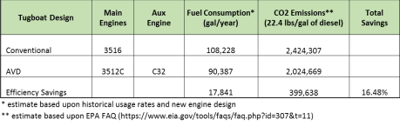Figure 4. Anticipated Fuel Efficiency and Carbon Dioxide Savings with AVDTM

Given the extended component life and reduced utilization of the main engine, there will be a dramatic savings in fossil fuels and lubricants, steel, and the many other materials used to make engines and parts. Quantifying this benefit is one of the objectives for this project.

Downsizing from two main engines to one smaller engine will also reduce the noise emanating from the tugboat. Quantifying this benefit is one of the objectives for this project.

5

Caterpillar: Confidential Green

**Innovation**

A conventional shaft line connects a single input—an 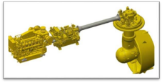

engine—to a single output—a propeller. But the

patented Caterpillar AVDTM is an integrated propulsion

system. As shown in Figure 5, it connects an engine and

a hydrostatic motor to a single propeller. This design

optimizes engine and system operation independently

of propeller speed, which translates to superior

performance and optimal fuel efficiency.

Figure 5. Integrated Propulsion System

From improved response, maneuverability, and positioning, to a lower noise profile, the advanced variable drive integrated propulsion system by Caterpillar Marine represents the next step in optimized vessel performance and efficiency. For more details about Caterpillar AVDTM , please refer to the video published at this link.

**Economic Benefits**

The AVDTM solution installed for this demonstration project is designed to generate a lower operating cost than traditional tugs. Optimized engine operation and utilization enables vessel to work at more efficient load points and utilize smaller auxiliary engines while at low loads, generating significant fuel savings. In turn, the ability to run with the main engines off reduces wear and tear and therefore, service and maintenance costs over the life of the engines and their components. In addition, AVDTM  motors and components are smaller and less expensive than battery-electric hybrid systems. The actual economic benefits are specific to each vessel design and as a result, vary.

**Transferability**

Given the proximity to populated coastlines, ports, and cities, it is especially important to minimize emissions for tugboats. However, the same is also true for dredges and the other workboats supporting dredging operations and marine construction projects. The AVDTM technology is not limited by application and as such, is highly transferable to other vessel types. For example, dredges of all types and sizes could also achieve similar results with AVDTM. Second, the system is scalable, which means it can be designed to meet any vessel power requirement. Third, the system is extremely flexible in terms of engine options – including constant speed or natural gas.

**Outreach and Education**

The technical lead, Nathan Kelly, was recently invited to deliver a technical presentation on Caterpillar Advanced Variable Drive technology at the Asia Pacific Marine (APM) conference in Singapore - 2018.

The engineering manager, Igor Strashny, delivered a technical presentation on Caterpillar Advanced Variable Drive technology at the Electric and Hybrid Marine World Expo in Florida - 2018.

Several press releases and an informational video have been published to promote the many benefits this technology provides. Caterpillar AVDTM

6

Caterpillar: Confidential Green